Jessica F.
My 4.5 year old son started going to Chatham School House 3 years ago. Prior to this he was at another local daycare center, where he would be constantly sick, and we'd be left to fend for ourselves as he cried every morning at drop off. I was so relieved we started at Chatham School House and my son was immediately greeted by a warm, friendly smile and 1-on-1 attention while he got settled for the day. The morning tears disappeared and he suddenly loved going to 'school' (and magically stopped getting sick as well!). Now that he is in the Pre-K room, he is able to get himself settled on his own for the most part, but we still receive the same warm greeting each morning, and the teachers are always ready and willing to provide additional 1-on-1 care on the rare 'rough morning'.
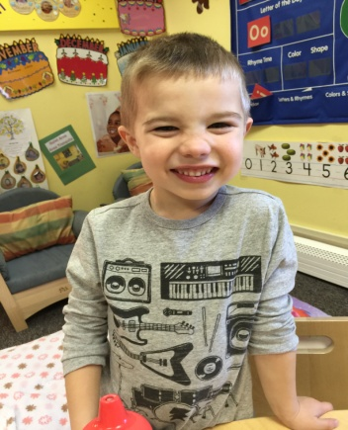

My younger son started at Chatham School House when he was 3 months old (he's now 16 months) and has enjoyed it from day one. It was such an easy transition for me to go back to work, knowing that both boys were in such good hands. I love that my boys are each able to learn and socialize with their peer groups, but still get to spend some time with each other during the day.
Rima and her staff are extremely accommodating with the occasional early drop off or late pick up time, and always put the needs of the children first. They care for my children like they are their own and the school truly feels like an extension of home.
I just cannot say enough good things about my family's experience at Chatham School House.

