# Mommy & Me Rules

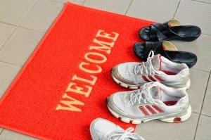

Please remove your shoes upon arrival.

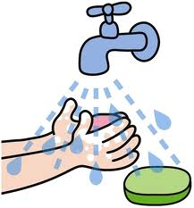

Please wash your child's hands upon arrival.

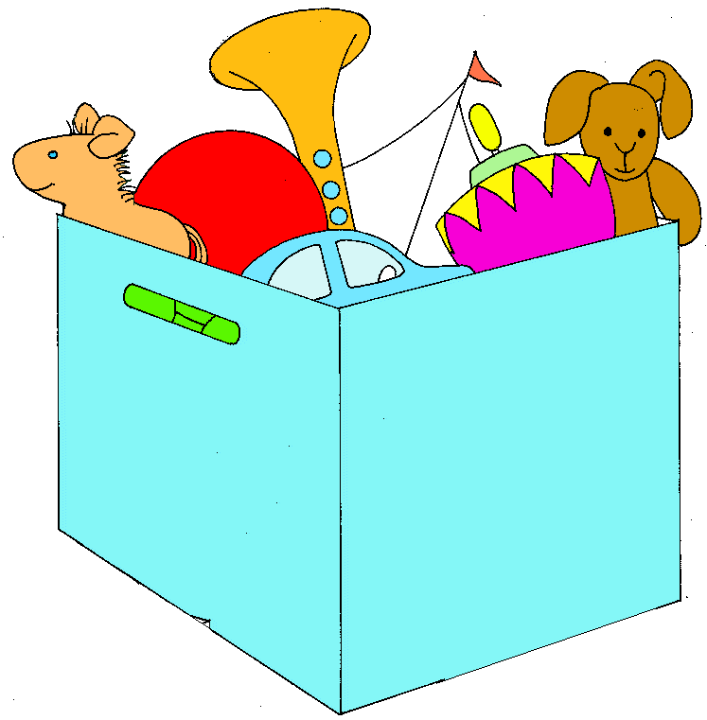

* **Meetup Group has access to first floor classrooms and outdoor playground, excluding the office as it is not child-proofed.**

Please put used toys in dirty toy bin.